MED D - SSI CCR PA Edit Process

Overview
PeopleSafe Research Process
Log Activity
Resolution time
Related Documents

Overview
These edits may only be done for SSI accounts and plans that confirm via the Client Information Form (CIF) that edit can be made.

Note: Edits are ONLY to be done through RX Claims by the Senior Team.

Top of the Document

PeopleSafe Research Process
Perform the steps below to research the rejected claim in PeopleSafe:
Step | Action
1 | On the Main screen, scroll down to the desired rejected claim.
2 | Click on the Prescription number hyperlink.  Result: Prescription Detail screen.
3 | On the Prescription Detail screen, scroll down to the Rejection code section and verify if the claim is rejecting for Refill-Too-Soon.
4 | Determine if the system shows a PA for the medication:  - Verify the GPI number on the claim (copy and paste into notepad).  - Review the claim to see if a PA is showing under the Override Type ID field.  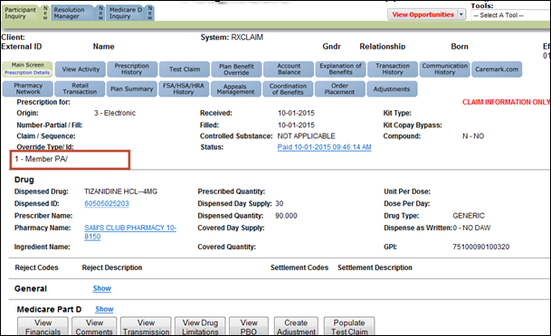  - If a PA does not show on the claim, review the PBO Tab.
5 | - Select the tab  - On the Plan Benefit Override screen, verify if there is a PBO with the GPI that matches the claim.  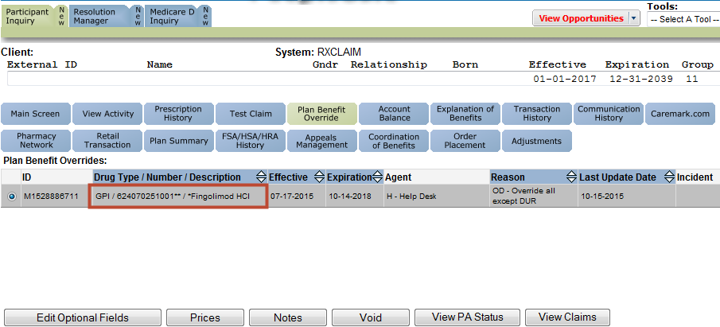
5 | If PA is… | Then…
5 | In The System | Transfer to the Senior Team.  Refer to MED D - When to Transfer Calls to the Senior Team and Basic Call Handling.
5 | Not in the System | If overrides are not handled by Caremark, follow the Plan Benefit override information in the CIF. Refer to Plan Benefit Overrides (PBO) CCR.
6 | Run a test claim. Refer to MED D - Test Claim.  - If claim still rejects, transfer to the Senior Team.  Refer to MED D - When to Transfer Calls to the Senior Team and Basic Call Handling.
7 | Document and close the call according to current policies and procedures. Refer to Med D – Call Documentation.

Top of the Document

Log Activity
PeopleSafe has the ability to auto-document the screens that are accessed by the CCR with the exception of the Transmission screen. Since the system will auto document the different screens, it is not necessary to use speed codes except 913 when you go to the Transmission screen.

Always type in required Notes in Activity Log field:
- Caller Name
- Reason of Call

Top of the Document

Resolution time
Real time

Top of the Document

Related Documents
Parent SOP: CALL-0048: Medicare Part D Customer Care Call Center Requirements-CVS Caremark Part D Services, L.L.C.
Abbreviations/Definitions: Abbreviations / Definitions

Top of the Document
Not To Be Reproduced Or Disclosed to Others Without Prior Written Approval
ELECTRONIC DATA = OFFICIAL VERSION – PAPER COPY – INFORMATIONAL ONLY

